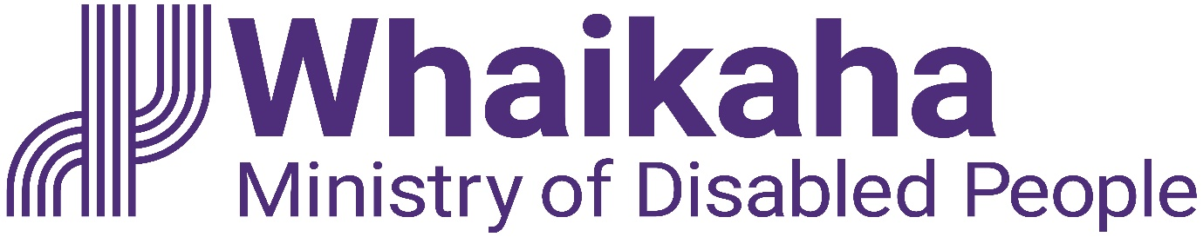

Intern
All-of-Government Whaikaha Internship Programme

Contents
All-of-Government Whaikaha Internship Programme 1
Working in the Public Service 1
Te Tiriti o Waitangi 1
About the role 2
How you will contribute 2
What you will bring 3

All-of-Government Whaikaha Internship Programme
The All-of-Government Whaikaha Internship Programme provides Deaf and disabled tertiary students and graduates with the opportunity to gain meaningful paid work experience across the New Zealand Public Service.
The programme aims to reduce barriers to employment, create pathways into professional careers and support government agencies to build more accessible and inclusive workplaces.

Working in the Public Service
In the public service we work collectively to make a meaningful difference for New Zealanders now and in the future. We have an important role in supporting both the current Government and successive governments to develop and implement their policies, as well as with its relationships with Māori under the Treaty of Waitangi.

Te Tiriti o Waitangi
Te Tiriti o Waitangi (the Treaty of Waitangi) underpins our work and we are committed to giving effect to Te Tiriti through kāwanatanga, rangatiratanga, and ōritetanga. Whaikaha values and supports the voices of tāngata whaikaha Māori, Turi Māori and recognises them in the context of their whānau, hapū and iwi. Our team works alongside tāngata whaikaha Māori, Turi Māori, whānau, hapū, iwi and communities to affirm their aspirations and work together to give effect to Te Tiriti.

About the role
Interns will undertake projects and assigned work within their host agency to gain knowledge and work experience within a public sector environment.
Alongside their work with their host agency, interns will take part in programme activities with the wider intern cohort, including induction, learning and development sessions, networking and career support.
Whaikaha will work closely with host agencies to meet the accessibility needs of interns, support reasonable accommodations and provide an accessible experience.

How you will contribute

Undertake assigned tasks
- Undertake tasks as assigned by your manager, or their nominated delegate.
- Work with colleagues using fresh perspectives and new thinking, to achieve work objectives.
- Build productive professional relationships with colleagues, and external stakeholders where required.

Projects
Work on projects that could include tasks such as:
- Organising documents, policies or procedures into an easy-to-use library or structure.
- Preparing presentations or reports.
- Reviewing an existing policy or procedure and conducting research to update or amend it.
- Conducting a peer-led informal evaluation or survey.
- Developing communications such as social media, film, or written documents.
- Organising work or social events.
- Other projects or tasks assigned by the manager or their nominated delegate.
Embedding te ao Māori
- Build more experience, knowledge, skills and capabilities (te reo Māori, tikanga, kawa, Te Tiriti) to engage with whānau, hapū and iwi.

Relationship Management
- Build and maintain collaborative and positive relationships across your host agency.
- Where required, establish and maintain sound working relationships with key contacts at relevant government agencies, non-government organisations, or other key stakeholders.

Risk Management
- Keep your manager informed of any issues that may impact the success of the organisation.

Contribute to your team
- Champion and contribute to a safe, respectful and accessible workplace culture. Embrace your role as a good team player by showing genuine care for your team, mahi and the communities we serve.
- Take personal responsibility for the wellbeing, health and safety of yourself and others. Follow safe working practices, report all incidents, hazards, and near misses, and familiarise yourself with how to respond in case of an emergency.
- Stay informed about emergency management and business continuity plans relevant to your business unit and team. Understanding these plans will help you respond appropriately in critical situations.
- Familiarise yourself and comply with all organisational policies, procedures, and guidelines.

What you will bring
While this section contains guidance as to the potential requirements for the role, it is not determinative or a complete list. We value the unique skills, strengths, perspectives and experiences that a diverse range of people may bring and will work with our people to make any reasonable accommodations needed to ensure they have a work arrangement suited to their specific needs.
To undertake this role successfully the incumbent will:
- Be a Deaf or disabled person, including tangata whaikaha Māori and Turi Māori, and bring lived experience and perspectives into the role.
Qualifications, experience, and knowledge
- Ideally, you will be in your final year of tertiary studies or have completed your tertiary studies in the last three years.
- Able to manage tasks and meet deadlines with support or strategies that work best for you.
- An interest in the Public Service and a willingness to learn and gain experience.
- Open to collaboration and building positive relationships.
- Openness to participating in group discussions and working with colleagues to achieve team goals.
- Curiosity, self-awareness, and openness to feedback.
- Familiarity with Microsoft Office products such as Excel, Word, PowerPoint and Outlook.

Position Description Updated: October 2026

