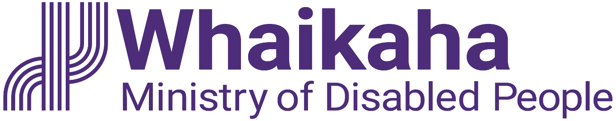
EGL Intern, Enabling Good Lives Christchurch
Adapted in 2023 by Accessible Formats Service,
Blind Low Vision NZ, Auckland
TN: Logo at the top of the page is: Whaikaha Ministry of Disabled People.

EGL Intern, Enabling Good Lives Christchurch
- Are you keen to make a difference for disabled people and whānau?
- Do you want to be an essential part of a team committed to transforming the disability support system alongside disabled people, whānau and communities?
- Full time with flexible accommodations available, fixed term role for one year
Have you heard about Enabling Good Lives? We have a fantastic opportunity for someone new to employment to gain professional experience within the Health and Disability Sector.

Ko wai mātou | About Us
Whaikaha—Ministry of Disabled People has a unique mandate of having responsibility to steward change across Government, while commissioning disability support services, as well as transforming how these services are commissioned and delivered.
Disabled people expect to have greater choice and control over the supports and services they receive to lead their best life. We are committed to this by strengthening relationships and working in partnership with disabled people, tāngata whaikaha Māori, Pacific disabled people and their whānau.
Whaikaha presents an exciting opportunity to make a real difference. The call for "Nothing about us, without us" is an integral part of our operation.

Mō tēnei tūranga mahi | About the Role
Enabling Good Lives Christchurch works to build relationships with disabled people and their whānau. The kaupapa is to support disabled people and whānau to build aspirational plans for living the life of their choosing. We are diverse, inclusive, and aim to reflect the population we serve.
The EGL Intern will support the team members out in the community and with office-based tasks. These will be based on your own employment goals and aspirations and could include:
- Assist team members with their paperwork and computer tasks
- Conduct research into mainstream options and opportunities for young people, on behalf of the connector team
- Review existing policies and procedures, documents and files and organise them into an easy-to-use library
This role would be perfect for someone who is just starting out on their employment journey and who has an interest in connecting with the disabled community. The role itself can be tailored to suit the successful candidate’s areas of interest and experience.
To find out more visit https://www.enablinggoodlives.co.nz/
Alternate formats of this advertisement and PD's can be found here whaikaha.govt.nz/chch-int

Koe wai koe | About you:
You will be passionate about a career in the disability sector and strive to achieve positive outcomes for disabled people and their whānau.
You will have good writing and communication skills and a keen desire to learn more about the transformation of the disability support system.
You may have little experience in paid employment, or this may be your first role, but you will be highly motivated either way!
To undertake this role successfully, you will be a disabled person or be able to establish credibility and trust with the disability community, as well as having empathy and an understanding of the unique and diverse experiences of disabled people.

Mō Te Tono, Mō Te Tirotiro Tātai Tūranga | Apply or View the Position Description:
whaikaha.govt.nz/chch-int

Salary range:
$54,239-$60,424

Tono Mai | We encourage you to apply:
Joining Whaikaha means being part of a whānau that celebrates the diversity each individual brings. Currently, just under 40% of our people identify as disabled people and we want this number to grow. We care about the wellbeing and success of our people and provide a supportive and inclusive working environment where people can thrive and be who they really are. We are committed to the application of Te Tiriti o Waitangi in all levels of our work.

Me He Pātai Anō | Further Enquiries:
We welcome applications from disabled people, or those who have a lived experience of disability through whānau or community involvement. Currently, just under 40 percent of our kaimahi identify as disabled people and we want this number to grow.

Te Tono | Application:
If you work for Whaikaha already—please apply through the myHR portal. You can do this by clicking the "Apply" button to complete the online application form and upload your CV and cover letter. This will ensure that your employee profile is visible as an internal candidate.
We want you to present this information in a way that plays to your strengths. For example, you may prefer to use video instead of a traditional CV and cover letter. You might want whānau or a friend to tell us about you or use social media or a PowerPoint presentation. Let’s kōrero about what you need to feel supported in your application at info@eglives.co.nz

Ka Kati Ngā Tono | Applications Close:
Monday 4 December 2023.
Whaikaha has adopted the Ministry of Social Development's (host agency) COVID-19 vaccination policy. This policy applies to all Whaikaha employees and encourages, but does not require, employees to be fully vaccinated for COVID-19 and its variants, unless the role is identified as requiring vaccination at the time.
End of EGL Intern, Enabling Good Lives Christchurch

