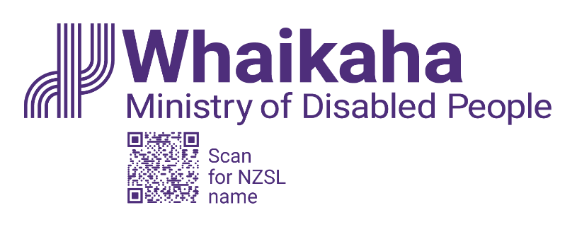

Senior Advisor

Adapted in 2024 by Accessible Formats Service,
Blind Low Vision NZ, Auckland
TN: The logo on the top of the page is Whaikaha Ministry of Disabled People.

Senior Advisor
- Wellington-based role
- Some flexibility in working arrangements available
- Work in an organisation committed to accessibility.
Use your advisory, administrative and project management skills to support the NZSL Board to maintain and promote NZSL.

Ko wai mātou | About Us:
Whaikaha – Ministry of Disabled People has a unique mandate of having responsibility to steward change across Government, while commissioning disability support services; as well as transforming how these services are commissioned and delivered.
Disabled people expect to have greater choice and control over the supports and services they receive to lead their best life. We are committed to this by strengthening relationships and working in partnership with disabled people, tāngata whaikaha Māori, Pacific disabled people and their whānau.
Whaikaha presents an exciting opportunity to make a real difference. The call for “Nothing about us, without us” is an integral part of our operation.

Mō tēnei tūranga mahi | About the Role:
As a Senior Advisor NZSL (New Zealand Sign Language) you will support the NZSL Board, and the Deaf community and community of NZSL users, to maintain and promote NZSL.
Key responsibilities include:
- Providing high quality advice and services to the NZSL Board including developing and distributing agendas and minutes, collating Board packs for meetings and monitoring action logs
- Supporting the maintenance and review of documentation to support NZSL Board systems and processes, such as Terms of Reference
- Supporting delivery of Ministerial correspondence and Official Information Act requests
- Facilitating and co-ordinating the development of cross-government actions to achieve the NZSL Strategy
- Supporting the Manager NZSL and other government agencies to meet their obligations under the NZSL Strategy, including regularly monitoring and reporting against the Strategy
- Managing and monitoring current grants and contracts, including relationships with contract and grant holders, and the lifecycle of new grants and contracts, including reporting
- Supporting work programme management, project delivery and co-ordination
- Maintaining an up-to-date understanding of the issues affecting the Deaf sector and Deaf people
Alternate formats of this advertisement and position descriptions can be found here whaikaha.govt.nz/sa-nzsl

Ko wai koe | About You:
NZSL knowledge is not essential but will be an advantage. You will understand or have an interest in NZSL and learning about:
- Deaf organisations and the Deaf world
- Issues impacting the lives of disabled people and their families
- Relevant sector organisations, including disabled people’s organisations, Māori, Pacific and ethnic organisations, and relevant international groups
You will have strong analytical and written skills. You will be proactive and able to apply good judgement and have excellent organisational skills.
You may have a background in a monitoring, governance or secretariat type role where you have provided advice and support to Boards or Committees.
You will be a great communicator and your ability to develop and maintain effective relationships will see you working with others in the Partnerships and Stewardship group and Whaikaha, and with the government and community sectors.
To undertake this role successfully, you will be a disabled person or be able to establish credibility and trust with the disability community, as well as having empathy and an understanding of the unique and diverse experiences of disabled people.

Mō Te Tono, Mō Te Tirotiro Tātai Tūranga | Apply or View the Position Description:
whaikaha.govt.nz/sa-nzsl

Tono Mai | We encourage you to apply:
Joining Whaikaha means being part of a whānau that celebrates the diversity each individual brings. Currently, just over 40% of our people identify as disabled people and we want this number to grow. We care about the wellbeing and success of our people and provide a supportive and inclusive working environment where people can thrive and be who they really are. We are committed to the application of Te Tiriti o Waitangi in all levels of our work.

Me He Pātai Anō | Further Enquiries:
We encourage you to talk to us about any support you need. We want you to present this information in a way that plays to your strengths. For example, you may prefer to use video instead of a traditional CV and cover letter. You might want whānau or a friend to tell us about you or use social media or a PowerPoint presentation. Let’s kōrero about what you need to feel supported in your application.
Contact us about the best way for you to apply by emailing us at: PeopleandCulture@whaikaha.govt.nz.

Te Tono | Application:
As part of you applying, we are keen to understand why you want to work for us.
We want to know about the unique strengths and skills that you bring. We also want to know what you need to be successful at work.
Click the ‘Apply Now’ button to complete the online application form and upload your CV and cover letter.
Please click the ‘Apply’ button to submit your application.
If you work for Whaikaha or MSD already – Please apply through the myHR portal. You can do this by clicking the ‘Apply’ button to complete the online application form and upload your CV and cover letter. This will ensure that your employee profile is visible as an internal candidate.

Ka Kati Ngā Tono | Applications Close:
For closing dates, please refer to this job position at whaikaha.govt.nz/sa-nzsl
Whaikaha has adopted the Ministry of Social Development's (host agency) COVID-19 vaccination policy. This policy applies to all Whaikaha employees and encourages, but does not require, employees to be fully vaccinated for COVID-19 and its variants, unless the role is identified as requiring vaccination at the time.
End of Senior Advisor

